**Team 22**

**Developed by** Ehtesham Shah, Rahat Nafees

Initial Date: 04/02/2025; Latest Update: 17/02/2025

**Software Requirements Specification**

**1. Introduction**

* 1. **Purpose**

The purpose of this Software Requirements Specification (SRS) document is to define the functional and non-functional requirements for the **Enterprise Pro Task Management System**. The system aims to provide improved project and task management capabilities, addressing the limitations of the existing Microsoft services used by the client. The system will allow users to create, assign, track, and manage tasks efficiently with different user roles and permissions.

* 1. **Product Scope**

The Enterprise Pro Task Management System is designed to facilitate seamless project and task tracking within an organization. The system will provide functionalities to:

* Create, assign, and manage tasks under specific projects.
* Search and filter tasks based on assigned dates, status, and projects.
* Define roles and permissions for different levels of users.
* Improve oversight and security of tasks and projects.
* Ensure updates and tracking of tasks at regular intervals.

By implementing this system, the organization will benefit from:

* Enhanced project management and task organization.
* Role-based access control for better security.
* The ability to track and manage tasks effectively.

**2. Overall Description**

**2.1 Product Functions**

The major functionalities of the system will include:

1. **Task Management**:
   * Create tasks with a title and details.
   * Assign tasks to users and set due dates.
   * Define task status: *New, In-Progress, Completed, Overdue*.
   * Search and filter tasks based on criteria such as assigned dates and project association.
2. **Project Management**:
   * Group tasks under projects.
   * Provide an overview of all projects.
   * Allow filtering of tasks by project and status.
3. **User Roles and Permissions**:
   * **User**: Can view assigned tasks, update task progress.
   * **Supervisor**: Read/edit access to amend tasks, add/remove users to/from projects.
   * **Admin**: Full access to create, modify, delete users, tasks, and projects.
4. **Security and Authentication**:
   * Internal login system with username and password.
   * Admin-controlled user registration.
   * Role-based access restrictions.
5. **Task Updates & Reporting**:
   * Users must provide updates on tasks instead of percentage-based progress tracking.
   * Task updates to be logged at least once a week.
   * Monthly task and project reports can be exported.

**2.2 Constraints**

* The system will be **internal only**; no external access is required.
* Minimal security setup, requiring only username and password authentication.
* No advanced security features like encryption or multi-factor authentication.

**2.3 Assumptions and Dependencies**

* The system assumes that all users have internal access credentials provided by an admin.
* Task updates will be made manually by users.
* Task deletions should have an undo or recovery option to prevent permanent loss.

**3. Functional Requirements**

| **ID** | **Requirement Description** |
| --- | --- |
| FR1 | Admins should be able to create tasks with a title, details, and assigned user. |
| FR2 | Tasks must have a status: *New, In-Progress, Completed, Overdue*. |
| FR3 | Tasks should have assigned and due dates for sorting and filtering. |
| FR4 | Users can update project progress through status changes. |
| FR5 | Supervisors should have read/edit access to all tasks, and add/remove users to/from projects. |
| FR6 | Admins should have full control to manage users, tasks, and projects. |
| FR7 | The system must allow filtering of tasks based on project, date, and status. |
| FR8 | Project updates should be required at least once a week. |
| FR9 | The system should allow exporting reports on tasks and projects monthly. |
| FR10 | Only admins can register users, ensuring controlled access. |

**4. UML Use Case Diagram**

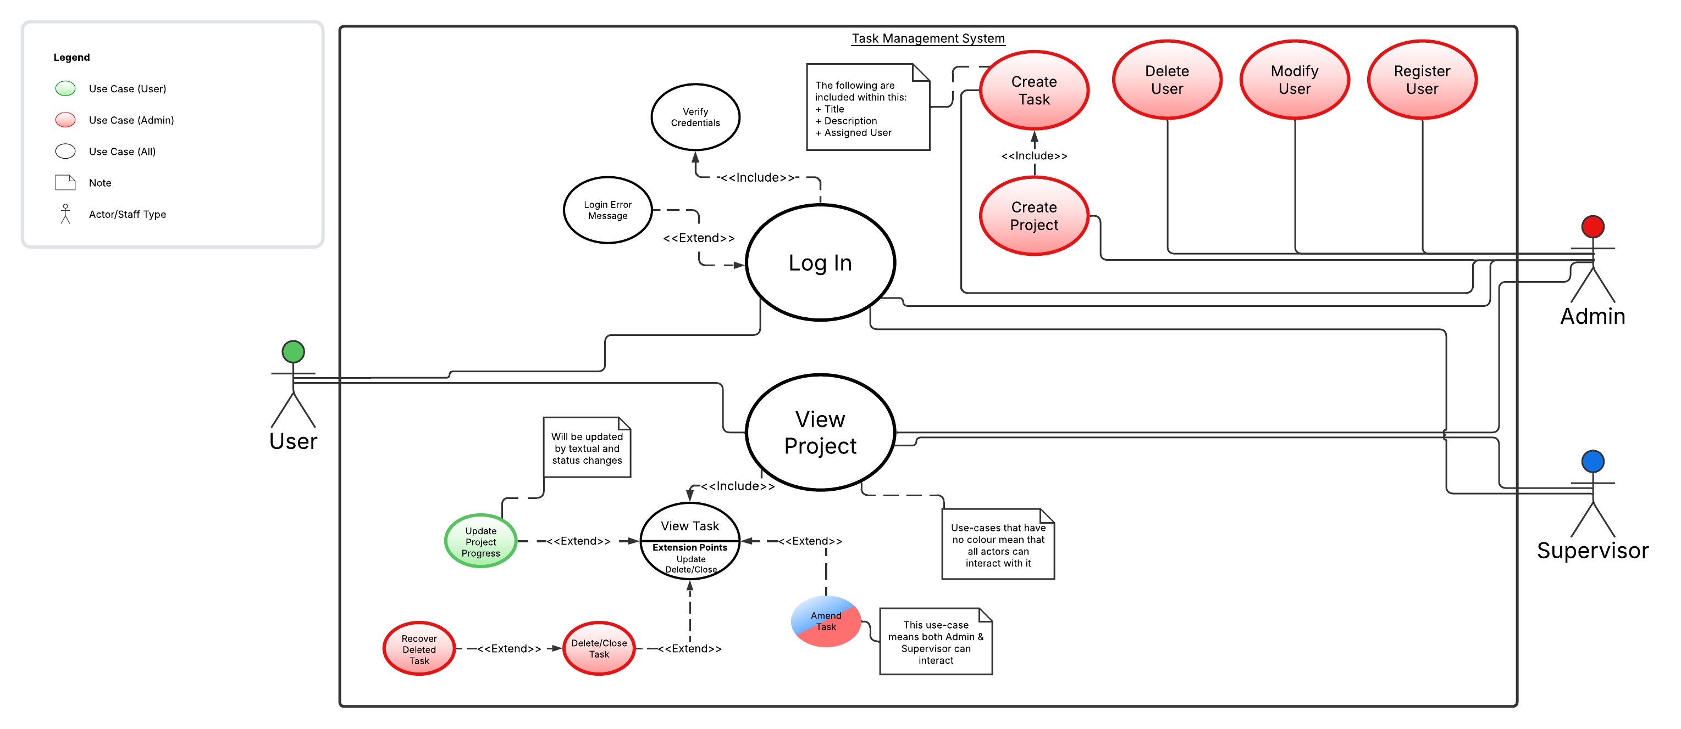

**5. Non-Functional Requirements**

|  |  |
| --- | --- |
| ID | Requirement Description |
| NFR1 | The system should be available 99% of the time during business hours. |
| NFR2 | The user interface should be intuitive and easy to navigate. |
| NFR3 | The system should support at least 50 concurrent users. |
| NFR4 | Response time for task queries should be less than 2 seconds. |
| NFR5 | The system should provide a simple authentication mechanism (username/password). |

**6. Risks, Ethical, and Security Considerations**

* **Risk of data loss**: A task recovery mechanism should be included.
* **Ethical Considerations**: Users should only have access to tasks relevant to them.
* **Security**: The system should ensure internal data privacy, avoiding unauthorized changes.

**7. Conclusion**

The Enterprise Pro Task Management System will address current project management inefficiencies by implementing a structured task management process with appropriate user roles, permissions, and tracking mechanisms. The focus will be on ease of use and task management efficiency rather than advanced security measures.

Client Signature:

Name: ___________________________ Title: ___________________________

Signature: ________________________ Date: ____________________________

Team Leader Signature:

Name: ___________________________ Title: ___________________________

Signature: ________________________ Date: ____________________________